**DBSCAN clustering**

URL: <https://www.analyticsvidhya.com/blog/2020/09/how-dbscan-clustering-works/>

<https://www.naftaliharris.com/blog/visualizing-dbscan-clustering/>

<https://colab.research.google.com/drive/1yZ0bg0cK6X84u6rawgRgoPzlgAmhVy2E?usp=sharing>

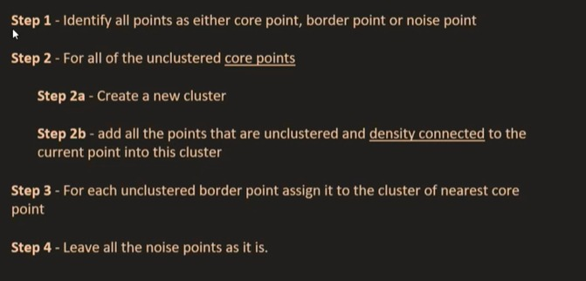

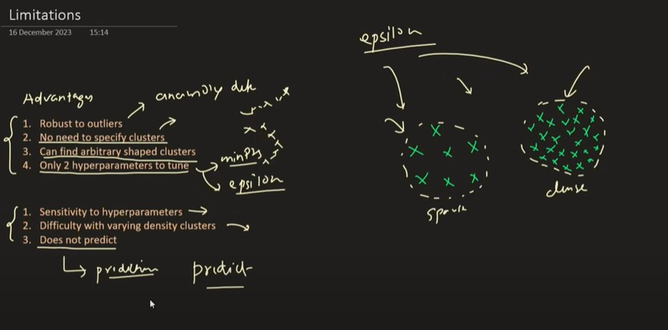

import numpy as np

import matplotlib.pyplot as plt

from collections import deque

from enum import Enum

# --------------------------

# ENUM for Point Type Labels

# --------------------------

class PointType(Enum):

UNVISITED = 0

CORE = 1

BORDER = 2

NOISE = 3

# --------------------------

# Generate Sample Data

# --------------------------

from sklearn.datasets import make_moons

X, _ = make_moons(n_samples=300, noise=0.05, random_state=42)

# --------------------------

# DBSCAN Hyperparameters

# --------------------------

eps = 0.2

min_pts = 5

# --------------------------

# Initialize data structures

# --------------------------

n_points = len(X)

point_types = [PointType.UNVISITED] * n_points # Track type of each point

cluster_labels = [-1] * n_points # Track cluster assignment

cluster_id = 0 # Start from cluster 0

# --------------------------

# Region query: find neighbors within eps

# --------------------------

def region_query(X, idx, eps):

neighbors = []

for i in range(len(X)):

if np.linalg.norm(X[idx] - X[i]) <= eps:

neighbors.append(i)

return neighbors

# --------------------------

# Expand cluster function

# --------------------------

def expand_cluster(X, idx, neighbors, cluster_id, eps, min_pts):

cluster_labels[idx] = cluster_id

point_types[idx] = PointType.CORE

queue = deque(neighbors)

while queue:

current_idx = queue.popleft()

if point_types[current_idx] == PointType.UNVISITED:

current_neighbors = region_query(X, current_idx, eps)

if len(current_neighbors) >= min_pts:

point_types[current_idx] = PointType.CORE

queue.extend(current_neighbors)

else:

point_types[current_idx] = PointType.BORDER

if cluster_labels[current_idx] == -1:

cluster_labels[current_idx] = cluster_id

# --------------------------

# DBSCAN Main Loop

# --------------------------

for i in range(n_points):

if point_types[i] != PointType.UNVISITED:

continue

neighbors = region_query(X, i, eps)

if len(neighbors) < min_pts:

point_types[i] = PointType.NOISE

else:

expand_cluster(X, i, neighbors, cluster_id, eps, min_pts)

cluster_id += 1

# --------------------------

# Visualization

# --------------------------

plt.figure(figsize=(10, 6))

# Define colors

colors = plt.cm.tab10(np.linspace(0, 1, cluster_id))

for i in range(n_points):

x, y = X[i]

label = cluster_labels[i]

ptype = point_types[i]

if ptype == PointType.NOISE:

plt.scatter(x, y, color='black', marker='x', label='Noise' if 'Noise' not in plt.gca().get_legend_handles_labels()[1] else "")

elif ptype == PointType.BORDER:

plt.scatter(x, y, color=colors[label], marker='s', label=f'Cluster {label} (Border)' if f'Cluster {label} (Border)' not in plt.gca().get_legend_handles_labels()[1] else "")

elif ptype == PointType.CORE:

plt.scatter(x, y, color=colors[label], marker='o', label=f'Cluster {label} (Core)' if f'Cluster {label} (Core)' not in plt.gca().get_legend_handles_labels()[1] else "")

plt.title("Manual DBSCAN with Core, Border, Noise Points")

plt.xlabel("X")

plt.ylabel("Y")

plt.legend()

plt.grid(True)

plt.show()

**What is Epsilon (ε)?**

**Epsilon (ε)** is a **distance threshold** that defines the **neighborhood radius** around a data point.

* It tells DBSCAN **how close points need to be** to each other to be considered **part of the same cluster**.
* In simpler terms: "How far should we look around a point to count how many neighbors it has?"

**🔍 How Epsilon is Used in DBSCAN**

DBSCAN uses ε in combination with **min_samples** (minimum number of points required to form a cluster):

**Based on ε, DBSCAN classifies each point as:**

| **Type** | **Condition** |
| --- | --- |
| **Core Point** | Has **at least min_samples points (including itself)** within ε-radius. |
| **Border Point** | Has **fewer than min_samples** within ε, but is **in the neighborhood of a core point**. |
| **Noise Point** | Not a core point and **not in the ε-neighborhood** of any core point. |

**📈 Example**

Assume:

* ε = 0.5
* min_samples = 4

For each point:

1. Draw a circle of radius 0.5.
2. Count how many points lie within that circle (including the point itself).
3. If count ≥ 4 → **core point**.
4. If not, but it lies within the circle of a core point → **border point**.
5. Otherwise → **noise (outlier)**.

**✅ Choosing the Right Epsilon**

Too small:

* Many points labeled as noise.
* May not find any meaningful clusters.

Too large:

* Different clusters may merge into one.
* Less accurate separation.

**🔧 Tip:**

Use a **k-distance plot** (plot distance to k-th nearest neighbor) to visually determine a good ε:

* The "elbow" in the graph suggests a suitable value for ε.

**🧠 Summary**

| **Parameter** | **Meaning** | **Role in DBSCAN** |
| --- | --- | --- |
| **ε** | Radius of neighborhood | Defines locality to find dense regions |
| Affects | Core point identification, cluster shape, sensitivity to noise |  |

Would you like the code to generate a **k-distance plot** to help pick the right epsilon?

**You said:**

what is density based clustering, DBSCAN full form, min point inside circle,dencity hyperplane

**ChatGPT said:**

Let’s break down everything clearly:

**📌 What is Density-Based Clustering?**

**Density-based clustering** is a technique that groups data points based on **regions of high density**, separating them from regions of **low density**.

* Unlike K-Means (which assumes spherical clusters), density-based methods can find:
  + Arbitrary-shaped clusters (like spirals or curves)
  + Noise or outliers (points in low-density areas)

**📘 What is the Full Form of DBSCAN?**

**DBSCAN** = **Density-Based Spatial Clustering of Applications with Noise**

It's a popular **density-based** clustering algorithm that:

* Groups together points that are closely packed
* Marks points in low-density areas as **noise**

**🔍 What is minPts in DBSCAN?**

**minPts** (minimum points) is a **hyperparameter** that defines:

The **minimum number of points (including the center point)** that must lie within a point's ε-neighborhood (a circle of radius ε), for that point to be considered a **core point**.

* If a point has **≥ minPts** in its ε-radius → it's a **core point**.
* If a point has **< minPts**, it may be:
  + A **border point** (near a core point)
  + Or **noise** (if not near any core)

**📏 What is the Density Hyperplane?**

While not an official DBSCAN term, "density hyperplane" typically refers to:

A **boundary** or **decision surface** that separates high-density regions (clusters) from low-density areas (noise/outliers) in **high-dimensional space**.

* In DBSCAN:
  + The algorithm **does not explicitly construct a hyperplane**, unlike SVM.
  + But you can think of ε as defining a "density boundary" for forming clusters.

**🧠 Summary Table**

| **Term** | **Explanation** |
| --- | --- |
| **DBSCAN** | Density-Based Spatial Clustering of Applications with Noise |
| **Density-based** | Clusters formed based on areas with many nearby points |
| **ε (epsilon)** | Radius of neighborhood (how far to look around a point) |
| **minPts** | Minimum number of points required inside ε to form a dense region |
| **Core Point** | Point with ≥ minPts in its ε-neighborhood |
| **Border Point** | Has < minPts but lies near a core point |
| **Noise Point** | Lies in low-density region; not part of any cluster |
| **Density Hyperplane** | Conceptual surface dividing dense clusters and sparse regions (not explicitly used in DBSCAN) |

Would you like to visualize DBSCAN with a real 2D example and animation?

**You said:**

what are core point, bordor, noise, Density connected points in DBSCAN

**ChatGPT said:**

Great! Let’s go deep into the core concepts of **DBSCAN** clustering. These definitions form the backbone of how DBSCAN identifies and groups clusters.

**📘 Key Concepts in DBSCAN**

**1. Core Point**

* A **data point** is a **core point** if:
  + At least **minPts** points (including itself) are within its **ε (epsilon) neighborhood**.
* This means the point lies in a **dense region**.

✅ Example: If ε = 0.5 and minPts = 4, and a point has 4 or more points within 0.5 radius, it's a core point.

**2. Border Point**

* A **border point** is:
  + **Not** a core point (i.e., fewer than minPts in its ε-neighborhood)
  + But it **lies within the ε-neighborhood of a core point**.
* It is close enough to be part of the cluster but **not dense enough** to be a core itself.

**3. Noise (Outlier)**

* A point is labeled **noise** (or **outlier**) if:
  + It is **not a core point**, and
  + It **does not lie within the ε-neighborhood of any core point**.

❌ These are isolated points in **sparse regions**.

**4. Directly Density-Reachable**

* A point **p** is **directly density-reachable** from point **q** if:
  + q is a **core point**, and
  + p lies **within ε** of q.

Only core points can have other points directly density-reachable from them.

**5. Density-Reachable**

* A point p is **density-reachable** from q if:
  + There exists a **chain of points**: q → p₁ → p₂ → … → p, such that each is **directly density-reachable** from the previous.
* The **chain starts from a core point**.

Note: This relationship is **not symmetric**.

**6. Density-Connected**

* Two points p and q are **density-connected** if:
  + There exists a point o such that **both p and q are density-reachable from o**.
* This relation **is symmetric**, unlike density-reachability.

**✅ Summary Table**

| **Term** | **Meaning** |
| --- | --- |
| **Core Point** | ≥ minPts points within ε |
| **Border Point** | < minPts, but near a core point |
| **Noise Point** | Not a core or border point |
| **Directly Density-Reachable** | p is within ε of core q |
| **Density-Reachable** | Chain of directly density-reachable steps |
| **Density-Connected** | Two points share a common reachable core point |

**🔁 Example Diagram (textual):**

less

CopyEdit

[Core]——[Core]——[Border]

|

[Noise] [Border]

Would you like a plotted visualization of these concepts with real 2D points to see them in action?

**You said:**

why we require DBSCAN while i already had k-Means, hyperparameters of DBSCAN, advantage and limitations in DBSCAN

**ChatGPT said:**

Great question! Let's clarify **why DBSCAN is needed**, its **hyperparameters**, and its **advantages vs limitations** — especially compared to K-Means.

**🤔 Why Use DBSCAN When K-Means Exists?**

| **Feature** | **K-Means** | **DBSCAN** |
| --- | --- | --- |
| Assumes cluster shape | Spherical (circular) | Arbitrary (any shape) |
| Requires cluster count (K) | Yes | ❌ No need |
| Handles noise/outliers | Poorly | ✅ Very well |
| Cluster density | Assumes similar size/density | Can handle varying densities |
| Sensitive to initial seed | ✅ Yes | ❌ No |
| Works with non-globular data | ❌ No | ✅ Yes |

**✅ Use DBSCAN When:**

* You **don’t know K** ahead of time.
* You expect **irregular or non-circular shapes**.
* Your data has **noise or outliers** you want to detect.
* Clusters have **different densities**.

**⚙️ Hyperparameters of DBSCAN**

1. **eps (ε)**:
   * Maximum distance to consider neighbors.
   * Radius of the neighborhood around a point.
2. **min_samples**:
   * Minimum number of points (including the point itself) required in ε-neighborhood to qualify as a **core point**.
3. **(Optional)** metric:
   * Distance metric used (e.g., 'euclidean', 'manhattan', etc.)

python

CopyEdit

from sklearn.cluster import DBSCAN

model = DBSCAN(eps=0.5, min_samples=5, metric='euclidean')

**✅ Advantages of DBSCAN**

| **Advantage** | **Description** |
| --- | --- |
| 🚫 No need to specify K | Automatically detects number of clusters |
| 🤖 Detects noise | Classifies low-density points as **outliers** |
| 🔄 Arbitrary shapes | Finds clusters of **non-spherical** form |
| 📉 Not sensitive to initialization | Unlike K-Means which depends on random centroids |
| 🔍 Works well for spatial data | Ideal for **GPS, image segmentation, etc.** |

**❌ Limitations of DBSCAN**

| **Limitation** | **Description** |
| --- | --- |
| 🔩 Sensitive to eps and min_samples | Small changes may affect results heavily |
| 🧩 Fails with varying density | Cannot detect clusters with **very different densities** |
| 🚀 Slow on high-dimensional data | Distance calculation is expensive in high dimensions |
| 💥 Can't handle very large datasets easily | Less scalable than K-Means (no mini-batch version) |
| 📊 Hard to tune | No clear rule for choosing best eps and min_samples (often needs a **k-distance plot**) |

**🔁 Summary**

| **Point** | **K-Means** | **DBSCAN** |
| --- | --- | --- |
| Needs K? | ✅ Yes | ❌ No |
| Handles noise? | ❌ No | ✅ Yes |
| Works with arbitrary shapes? | ❌ No | ✅ Yes |
| Hyperparameters | n_clusters, init, max_iter, etc. | eps, min_samples, metric |

Would you like a **side-by-side plot** showing how K-Means and DBSCAN behave differently on the same dataset?

2/2

**You said:**

uses of DBSCAN if we can't do predictions for new point, what is dendograph,outlier vs noise

**ChatGPT said:**

Great set of questions! Let’s address each one thoroughly and clearly.

**🔍 1. Uses of DBSCAN if We Can’t Do Predictions on New Points?**

You're right that **DBSCAN is not inherently designed for prediction (classification)** like K-Means or supervised learning algorithms.

However, **DBSCAN is extremely useful for:**

| **Use Case** | **Explanation** |
| --- | --- |
| **Exploratory Data Analysis (EDA)** | Helps to **discover hidden patterns** and **groupings** in unlabelled data. |
| **Outlier Detection** | Classifies low-density points as **noise**, ideal for **fraud detection**, **anomaly detection**, etc. |
| **Spatial Clustering** | Works well for **geospatial data**, e.g., clustering regions based on GPS coordinates. |
| **Preprocessing** | Can be used to **filter noise** or **group similar data** before applying supervised learning. |
| **Image Segmentation** | Identifies dense pixel areas (useful in medical or satellite images). |

**🔁 For New Points?**

* DBSCAN **doesn’t learn a model** → it doesn’t generalize like a classifier.
* For prediction:
  + Use **HDBSCAN**, which supports **soft clustering** and **probabilistic assignment**.
  + Or treat DBSCAN as **preprocessing** → cluster first, then train a classifier on labeled clusters